# Setup Challenge 4:

# Alice, Or and The Safe

* I named this challenge Alice and Or because of my close friend Or Givati, who also happened to do this course with me, and his wife name is Alice, which reminds “Alice and Bob”.
* This challenge story: Or and Alice sending messages to each other on port 9999 on a tcp non-encrypted connection, your mission is to open the safe discovering the code from their conversation using a sniffing tool like wireshark.

1. 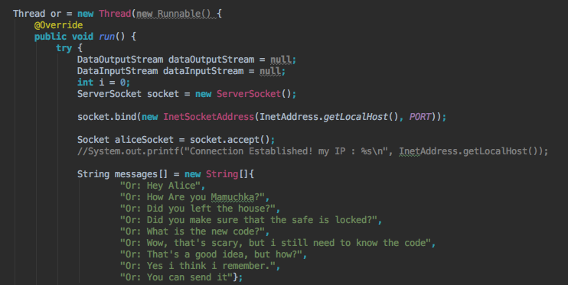Start from creating a Server (Or) and a Client (Alice) on different threads, and write some messages for each of them to send to each other.

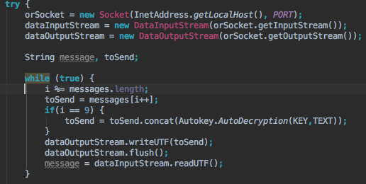

1. Send the messages by turn, from one the other in an infinite loop to make it easier for the user to solve
2. In some point Alice wants to send the safe code in an encrypted message, so I chose Auto-Key encryption for that, implying that in a previous message:

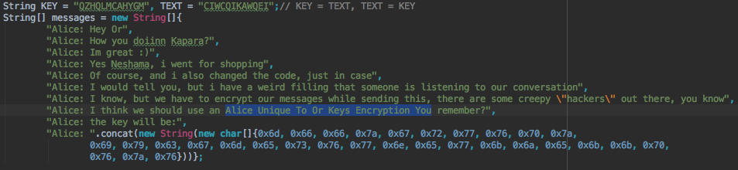

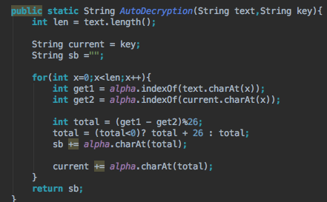Auto Key is the acronyms for: “Alice Unique To Or Keys Encryption You”, then I took the password, encrypted it, converted it to hex so it’ll be harder to reverse engineer this challenge more than solving it.

1. 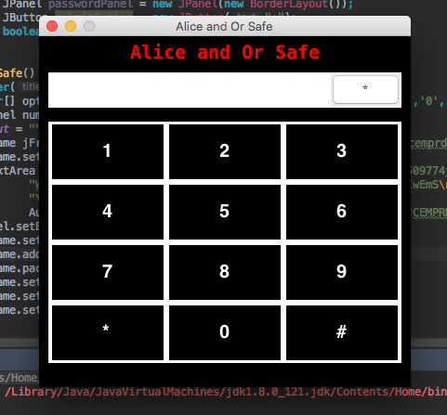Create the Safe GUI with buttons like in a real safe, a text field to enter the password and a button to submit the password:
2. 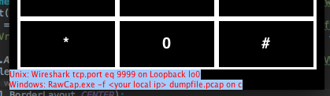Add an invisible text box(Like in my previous challenge), and give the user a hint about what he need to do in order to crack the code:
3. 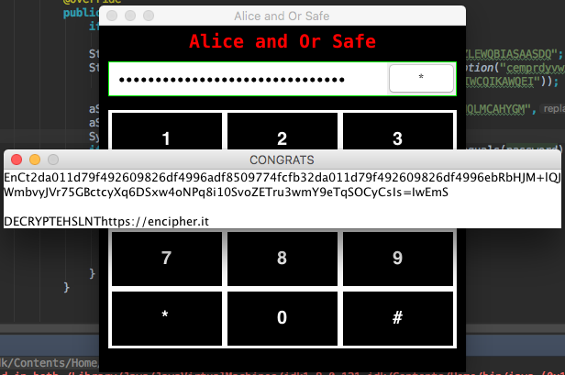After doing that, make sure the user knows when he’s wrong and create a JFrame that will pop up when the user enters the right password:

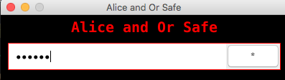

1. Hiding the flag:
2. Use [The Textsaver](https://textsaver.flap.tv/) to hide your flag, and lock it with the same key from the auto-key encryption from their

conversation: ORLOVESALICE  
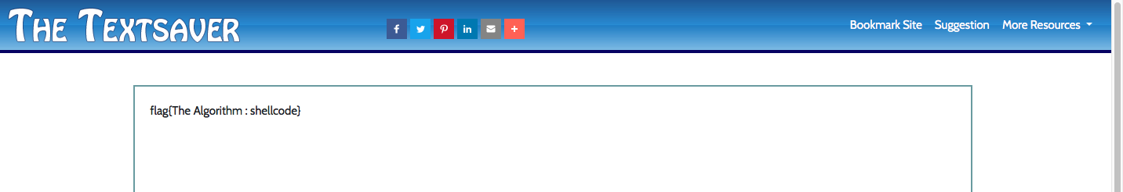

1. The site will give you a link for that text:

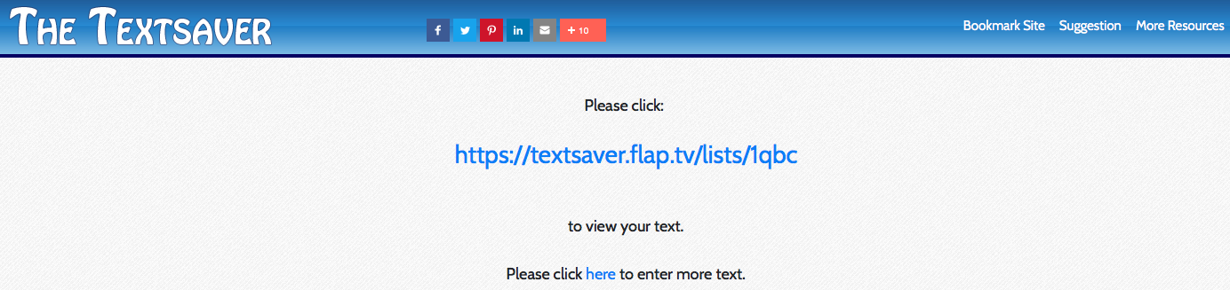

1. Encrypt the link using [encipher.it](https://encipher.it/) and use the same password again:

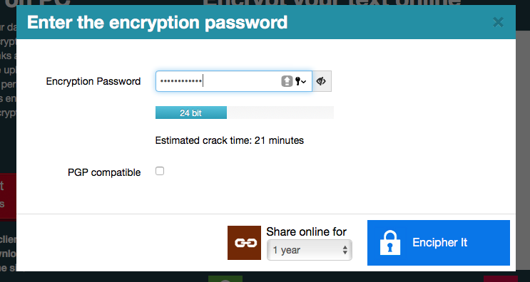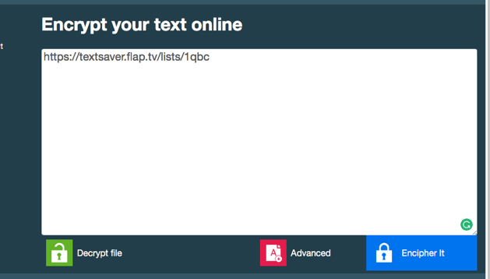

1. 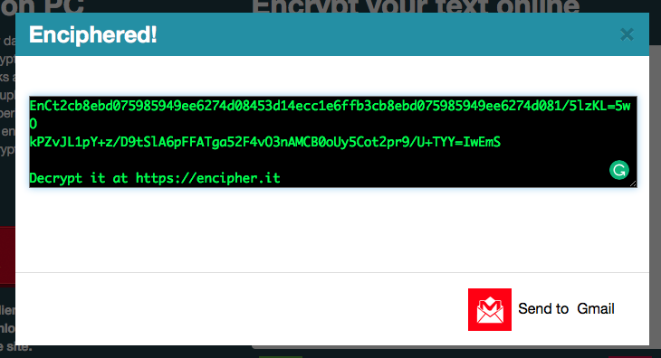The site will give you the encrypted text and the site to decrypt it:
2. Put that text in the “Congrats” window text box.

